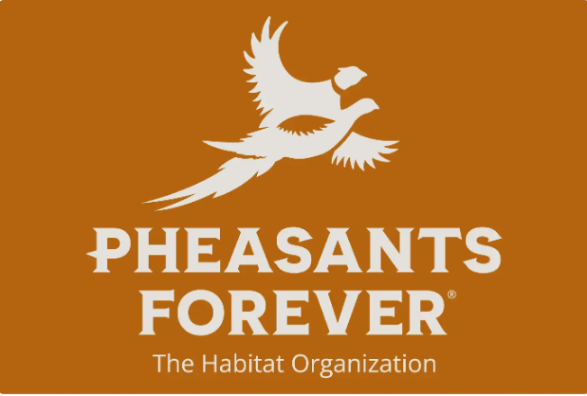 **Fond du Lac County Pheasants Forever Chapter 0582**

**Rental Contract for 8’ Aitchison No-Till Drill**

Landowner/Renter Name_________________________________________________________

Landowner/Renter Adress________________________________________________________

Location where drill will be used___________________________________________________

The landowner/renter agrees as follows:

* To provide suitable equipment with operator to pull the drill.
* To assume all liability in case of accident while the equipment is in use or being transported (if being transported by the landowner/renter).
* To pay FDL Pheasants Forever Chapter 0582 for the cost of repairs to the machine in the event that it is damaged through the fault or neglect of the landowner/renter.
* Pickup/Delivery date and time: _______________________________________

Return Delivery/Drop off date and time: ________________________________

Number of acres_____________________

* To pay FDL County Pheasants Forever Chapter 0582 for the use of the drill at the following rate:
  + ____________________
  + Full payment should accompany this contract.
  + Make all checks payable to **FDL COUNTY PHEASANTS FOREVER CHAPTER 0582.**

_____________________________________________ Date_____________________

Signed by (Landowner/Renter signature)

*A $50 refundable deposit must accompany this contract. (Refunded when drill is returned cleaned.)*